Confidentiality Agreement / NDA

1. Header Information

The date of this Agreement is 8th of January, 2021 (the "Signing Date") This is an agreement between: 1. Erika Katherine Ferszt/Moodally of Via Giovanni Segantini 24 Milan, Italy ("I/We/Us" in this Agreement); and 2. Naijeria Toweett of 2511, Greenfields Phase 7B, Donholm , Nairobi , Kenya. ("You" in this Agreement).

2. Overview   
 2.1 We and You have agreed to carry out a project which will involve Us supplying to You information which is confidential to Us. We wish to protect our interests in that information on the basis that We have verbally agreed and which is explained in this written Agreement.

3. The Project   
 3.1 The Project is the mood management app known as Moodally.

4. Confidential Information   
 4.1 "Confidential Information" means all information, including access to base code, relating to our business which is given to You in any way before or after the date of this Agreement, or which comes to your knowledge in connection with the Project. This includes:

4.1.1 Information which is marked "confidential" when it's given to You or is obviously confidential when it's given to You; and

4.1.2 Spoken Information which We told You when We gave it to You was confidential; and

4.1.3 any note or record made by You of any spoken information which is confidential; and;

4.1.4 any Information obtained through discussions between the employees, contractors, agents and advisors of either Us or You or both of Us; and

4.1.5 any copy of any of these sources of the Information.

5. Your Responsibilities   
 5.1 In return for Us giving You Confidential Information, You agree that for a period of 2 years from the date of this Agreement, or the last date of our interaction:

5.1.1 You will keep the Confidential Information secret and confidential;

5.1.2 You will not give or allow the disclosure of any Confidential Information to anybody else;

5.1.3 You will not use the Confidential Information for anything except the Project;

5.1.4 You will not make any copies of the Confidential Information or You will only make the limited number of copies of the Confidential Information which are genuinely required for the Project; and

5.1.5 You will take all reasonable steps to ensure the confidentiality of the Confidential Information.

6. Disclosure to Courts

6.1 If You have to disclose Confidential Information by order of a court or other public body You may do so.

7. Exceptions to Confidentiality Responsibilities   
 7.1 Your responsibilities under Section 5 do not apply to Confidential Information that is known or becomes publicly known, other than because You or someone You gave the information to breached the terms of this Agreement.

8. Return of Information and what happens after the end of the Agreement   
 8.1 If We ask You to, or at the end of this Agreement, You will:

8.1.1 Return to Us all the documents and any other material that contains any of the Confidential Information, including all copies made by anybody for You;

8.1.2 Permanently delete all electronic copies of Confidential Information from your computer systems; and

8.2 Following the date of any termination of this Agreement, or any return of Confidential Information to Us, You will not make any further use of the Confidential Information; and your responsibilities under this Agreement will continue.

9. Breach of Agreement

9.1 You understand and agree that any breach of this Agreement could cause serious damage to Us and that damages awarded by a court would not compensate Us. So, if there is a breach of this Agreement or You threaten to breach it You agree that We are entitled to ask a law court for an injunction against You.

9.2 You will reimburse Us for all costs or expenses which We have to pay because You breached this Agreement.

10. Protecting the Project

10.1 You agree not to work against Us in relation to the Project.

11. General Terms

11.1 You agree that We have and will continue to have all rights of ownership in the Confidential Information.

11.2 This Agreement does not grant You any licence or rights in the Confidential Information.

11.3 We do not have to disclose to You, continue disclosing, or update any Confidential Information.

11.4 Neither of Us has to negotiate or continue negotiating with each other in respect of the Project. Either of Us may withdraw from such negotiations at any time without any responsibility apart from your responsibilities in relation to the Confidential Information.

11.5 This Agreement will be interpreted in accordance with English law. If there are any disputes they may only be dealt with by the courts of England and Wales.

12. Signing

This Agreement is signed on the date mentioned at the beginning of this document. Each of the Parties agrees to the terms of this Agreement by signing below:

1. Signed by Erika Katherine Ferszt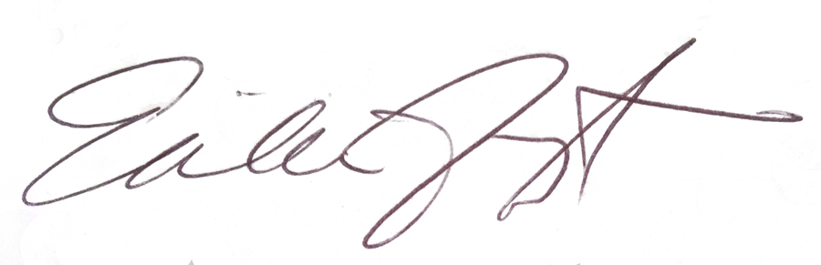

______________________________________________________

On behalf of Erika Katherine Ferszt/Moodally ("I/We/Us")

2. Signed by Naijeria Toweett

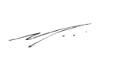

______________________________________________________

On behalf of Naijeria Toweett ("You")